AS Level Business Studies

A guide to help you prepare yourself for studying AS Level Business Studies

Book Recommendations

- The 7 Habits of Highly Effective People by Stephen Covey
- Finding my Virginity: The new Autobiography by Richard Branson
- Legacy by James Kerr
- Age of Discovery: Navigating the Risks and Rewards of Our New Renaissance: (Ian Goldin & Chris Kutarna)
- Alibaba: The House that Jack Ma Built (Duncan Clark) – The rise of the Chinese corporate giant
- Art of Strategy (Dixit and Nalebuff) – especially good for Game Theory examples and analysis
- If I Could Tell You Just One Thing...: Most Valuable Advice from Remarkable People: (Richard Reed)
- Risk Savvy - How to make good decisions (Gerd Gigerenzer) – the world of heuristics and risk management
- The Everything Store: Jeff Bezos and the Age of Amazon (Brad Stone) – a great page turner
- The Great Convergence: Information Technology and the New Globalization (Richard Baldwin)
- The Upstarts: How Uber and Airbnb are changing the world (Brad Stone) Follow up to his work on Amazon
- Thinking Fast and Thinking Slow: (Professor Daniel Kahneman) – the classic Kahneman epic

Movie/Documentary Recommendations

Becoming Warren Buffett (2017)
With a net worth of over $60 billion, Warren Buffett is truly a one-of-a-kind billionaire. An enormous amount of invaluable knowledge is offered up in Becoming Warren Buffett, from which we can extract important life lessons from the humble billionaire, his family and his peers.
The legendary investor still lives in a modest home in Omaha and drives himself to the office every morning to manage Berkshire Hathaway. This documentary chronicles Buffett's evolution into one of the wealthiest and most respected men in the world. The film takes us on a journey in which we see how the legendary investor started out as an ambitious, numbers-obsessed boy from Nebraska and ended up becoming one of the richest and most respected men in the world.

Generation Startup (2016)  Follow 6 recent college graduates who are would-be entrepreneurs over 17 months. We watch how they put everything on the line as they try to launch startups in Detroit. Generation Startup puts a human face on the Millennial startup culture by showcasing these young entrepreneurs’ successes and failures, how they wrestle with self-doubt and uncertain rewards.  The film takes us to the front lines of entrepreneurship in America. It celebrates risk-taking and urban revitalization, and gives an honest and in-the-trenches look at what it really takes to launch a startup. The film received rave reviews from successful entrepreneurs like Arianna Huffington and Daymond John | 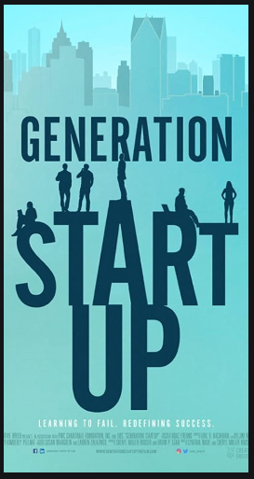
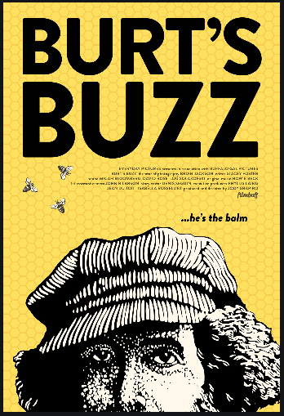 | Burt’s Buzz (2013)  This humorous, authentic and compelling documentary tells the story of Burt Shavitz, a reclusive beekeeper who reluctantly became one of the world’s most recognizable brand identities. Burt's Buzz pays tribute to Shavitz, the man behind Burt’s Bees.  He is a quiet curmudgeon who dislikes middle-class comforts, enjoys solitude and forgoes nearly all technology. Viewers also learn about Shavitz's complicated relationship with co-founder Roxanne Quimby, who eventually bought Shavitz out of the business. Quimby later sold the business to the Clorox company for a staggering $177 million.
Steve Jobs: One Last Thing (2011)  The PBS documentary Steve Jobs: One Last Thing is a tribute to the visionary entrepreneur who was the co-founder and CEO of Apple. Jobs died in 2011. During his time at the helm of Apple he managed to change much of how we work, interact and communicate with one another.  The documentary examines how his talent, style and imagination have shaped all of our lives and looks at the influences that molded the man himself. The film takes viewers through Jobs' career trajectory and the development of his memorable product presentations. It's a moving look at the life of a man who pursued his passions and changed the world. | 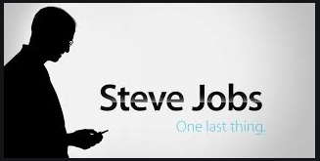
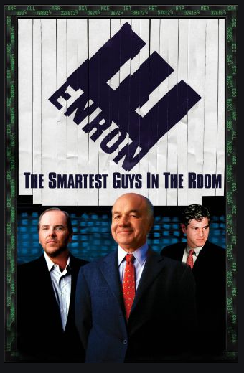 | Enron: The Smartest Guys in the Room (2005)  This documentary tells the incredible story of Enron and the executives that ran the company. Enron: The Smartest Guys in the Room is the inside story of the spectacular rise and fall of one of the most scandal-ridden corporations in American history.  Based on the best-selling book of the same name, this film takes a look at the collapse of the once seventh-largest company in the United States, where executives misappropriated billions of dollars, leaving investors scrambling and ruining the life savings of thousands of employees. However, while they may have committed terrible crimes and gotten away with them for close to a decade, you can’t ignore the fact that these guys were actually brilliant men and brilliant leaders.

Research Activities
Research, reading and note making are essential skills for A level Biology study. For the following tasks you are going to produce ‘Cornell Notes’ to summarise your reading.

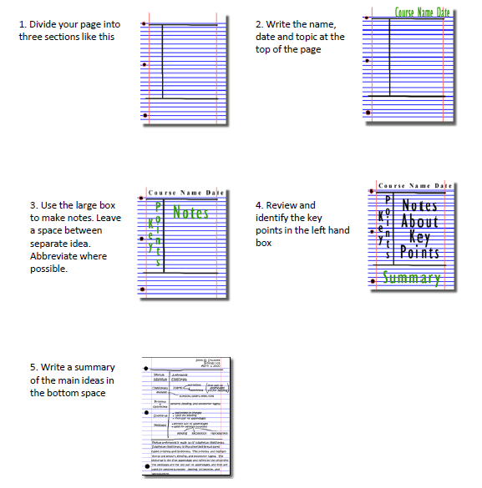

Images taken from http://coe.jmu.edu/learningtoolbox/cornellnotes.html

Getting ready to study…..

A level Business Studies will use your knowledge from GCSE and build on this to help you understand new and more demanding ideas. You are able to study Business Studies at A Level without previously studied the subject at GCSE. Complete the following tasks to make sure your knowledge is up to date and you are ready to start studying.
Task 1:
Find two Business articles that you find interesting, one on a UK based business and the other on a business that operates in another country. Summarise them in 50 words per article. The news articles must be within the last 3 months. Please include a link to the article you are summarising.

Task 2
Vicky Morgan is the managing director of Yorkshire Vets. She currently employs 18 staff; this includes a mixture of vets, vet nurses and administrative staff. As she has seen profits rise over the last few years Vicky is looking to expand her practice. Her two options are to invest in a Hydrotherapy pool for dogs, or to buy another x-ray machine that she can use in house. The x– ray machine would mean that her competitors would send their patients to her for a fee. The Hydrotherapy pool will cost £2,400 and thex-ray will cost £5,500.
She already has staff that are trained in Hydrotherapy but would need to get some of her staff trained to use the x-ray at a probable cost of £250 per member of staff.
The following table represents the return that Vicky expects the new machines to bring to the business over the next five years.
 | Hydrotherapy Pool £ | X-Ray Machine £
Year 1 | 450 | 1120
Year 2 | 600 | 1220
Year 3 | 875 | 1000
Year 4 | 960 | 1800
Year 5 | 1020 | 1600

Which one should Vicky invest in? Fully justify your answer.
Your answer should be a minimum of half an A4 page.

Task 3:
Businesses all over the country are feeling the effects of the Coronavirus as the whole of UK and many part of the world remain on lockdown. Your task is to investigate the types of businesses in the table below and the impact the lockdown is having on them. A challenge task will be to consider actions that they may take to alleviate the problems they are facing in the short, medium or long term.

Create a table like the one below to record your findings:
Types of Business Ownership | Benefits of type of ownership | Drawbacks of type of ownership | Real life examples of this type of ownership (at least 2) | Impact of Coronavirus/Lockdown | Challenge: How can each business respond to ensure the survival of their business?
Sole Trader |  |  | e.g. Plumber
Public Limited Company (UK) |  |  | e.g. Sainsbury’s
Multinational Company |  |  | e.g. Disney
It is important that you undertake research to complete this task e.g. Watch news reports and read newspaper articles. List your sources on information.
One useful resource is the tutor2u website;
https://www.tutor2u.net/business/reference/business-impact-and-response-to-the-coronavirus-crisis

Task 4

Read the BBC news Article on the boss who decided to pay everyone 70K.
https://www.bbc.co.uk/news/stories-51332811

1. Write a paragraph explaining whether you agree or disagree with this approach.
2. Explain what you feel are:
a. The benefits of such a scheme?
b. The drawbacks of such a scheme?

In BOTH a. and b. consider and comment on SHORT TERM [immediate] and LONG TERM [in a year or more] issues.

Task 5
Use the following website to make notes of the first unit content Business Opportunities
https://resources.wjec.co.uk/Pages/ResourceSingle.aspx?rIid=737. Notes should be take on the following topics -
1 - Enterprise and business planning
2 - Market structure types and segmentation
3 - Demand and supply
4 - Market research
5 - Consumer protection
6 - Business structure
7 - Stakeholders
8 – Location
9 - Business finance
10 - Costs and break even

Task 6

Listen to the Podcast- Business of Music

https://www.bbc.co.uk/sounds/play/b0785ppx

Answer the following questions:
1. What is a royalty regarding the music industry?
2. How has the music industry changed over the last 10 years?
3. Why did the album industry collapse?
4. Why did Taylor Swift withdraw her music from Spotify?
5. Give three new facts you have learnt about the business of music.

Task 7
WATCH: Episode 1 of Tricky Business
https://www.channel4.com/programmes/tricky-business/on-demand/39825-001
Write an A4 information profile about Oli (The entrepreneur)
You should include:
I. About him as an entrepreneur
II. About his business
III. Risks he has taken and is going to take going into London.

Task 8
Watch the Business as usual Podcast
https://www.youtube.com/watch?v=FgObj6HmSaU

1. Make notes of the various topics
2. Create a PROS and CONS table about furloughing.
3. What might be the long-term issues for the economy?

Task 9
Watch the Channel 5 documentary ‘Inside Aldi’
https://www.channel5.com/show/inside-aldi-britains-biggest-budget-supermarket/

Visit this website to download and complete 4 interactive worksheets:
https://time2resources.co.uk/blog/preparing-year-11-students-for-year-12-business-qualifications-with-inside-aldi/

Social Media

Suggestions of people to follow on Twitter:

- Mrs Briggs – Business and Economics teacher @thebizteach

- Adrian Murray – Creator of BusinessEd (formerly Business Studies Online) and it’s associated digital resources @BusinessStudies

- Tutor2u Business – All the latest teaching and learning resources and support from the tutor2u Business Channel @tutor2uBusiness

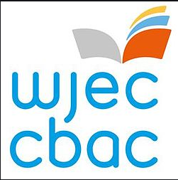
Keeping it Fresh……..

It is important to keep the knowledge you have gained at GCSE fresh in your mind ready to start your A levels in September.
Why not spend some time looking over some past papers and using the mark schemes to assess how well you’ve done.

Business GCSE Units 1 and 2 – Past Papers and Marking Schemes:
https://www.wjec.co.uk/qualifications/business-gcse/#tab_pastpapers

NB – You do not need to have studied GCSE Business in order to move on to A Level Business Studies.

Planning Ahead…….

In order to prepare yourself for further study, have a look at the resources below:
WJEC Specification – GCE AS/A Level in Business | https://www.wjec.co.uk/media/qdyp1wcl/wjec-gce-as-a-level-business-specification-formatted-2.pdf
WJEC Specimen Assessment Materials | https://www.wjec.co.uk/media/ipcdvl0q/wjec-gce-as-a-level-business-sams-formatted.pdf
WJEC Past Papers and Marking Schemes | https://www.wjec.co.uk/qualifications/business-as-a-level/#tab_pastpapers
Summer stay at home business challenges | https://resources.wjec.co.uk/Pages/ResourceSingle.aspx?rIid=3246

