A’s’ Level Religious Studies



**Planning Ahead…….**

*In order to prepare yourself for further study, have a look at the resources below:*

|  |  |  |  |
| --- | --- | --- | --- |
| WJEC Specification – GCE AS/A Level in Religious Studies |  | WJEC Specimen Assessment Materials |  |
| WJEC Past Papers and Marking Schemes |  | A level Religious Studies: Schemes of Learning |  |



**Book Recommendations**

*Reading for and beyond the course:*

**Christianity**

* Gwilym, G. ap (2016) - WJEC/Eduqas Religious Studies for A Level Year 1 & AS Christianity, Illuminate, ISBN:9781908682956
* Ford, David (2013) - Theology: A Very Short Introduction (Oxford University Press), ISBN:0199679975
* McGrath, Alister (2011) - Christian Theology: An Introduction, WileyBlackwell), ISBN:9781444335149
* McGrath, Alister (2006) - The New Lion Handbook of Christian Belief, Lion ISBN:0745951554
* McGrath, Alister (2006) - Christianity an introduction, Wiley-Blackwell, ISBN:1405108991
* Thiselton, Anthony (2015) - The Thiselton Companion to Christian Theology, Eerdmans, ISBN:0802872328.
* Woodhead, Linda (2014) - Christianity: A Very Short Introduction, Oxford University Press, ISBN:0192803220

**Islam**

* The Holy Qur'an: – there are a number of translations (or 'interpretations') of the Qur'an.
* Generally, however, Yusuf Ali’s translation is the one most approved by Muslims:
* Ali, Yusuf (2000) - The Holy Qur'an: Arabic Text with English Translation, Kitab Bhavan, ISBN:8171512186
* Armstrong, Karen (2001) - Muhammad: Biography of the Prophet: A Biography of the Prophet, Phoenix, ISBN:1842126083
* Aslan, Reza (2011) - No God But God: The Origins, Evolution and Future of Islam, Arrow, ISBN:0099564327
* Hewer, Chris (2006) - Understanding Islam: The First Ten Steps, SCM Press, ISBN:0334040329
* Gray, R. (2016) - WJEC/Eduqas RS for Yr1/AS – Islam, Illuminate, ISBN:9781908682987
* Maqsood, Ruqaiyyah Waris (2010) - Islam - An Introduction: Teach Yourself, ISBN:1444103474
* Ramadan, Tariq (2008) - The Messenger: The Meanings of the Life of Muhammad, Penguin, ISBN:0141028556
* Ruthven, Malise (2012) - Islam: A Very Short Introduction, Oxford University Press, ISBN:0199642877
* Sarwar, Ghulam (2006) - Islam: Beliefs and Teachings, Muslim Educational Trust, ISBN:0907261450
* Turner, Colin (2011) - Islam: The Basics, Routledge, ISBN:0415584922
* Watton, Victor (1993) - Islam: A Student's Approach to World Religion, Hodder Education, ISBN:0340587954

**Book Recommendations**

*Reading for and beyond the course:*

**Judaism**

* The Hebrew Scriptures: Torah and Talmud
* The Tenakh – there are a number of translations of the Tenakh. You will find it useful to compare English editions. Generally, however, the Jewish Study Bible is one of the most recent compilations that has been well received:
* Berlin, Adele (2014) - The Jewish Study Bible, Oxford University Press, ISBN:0199978468 ISBN-13: 978-0199978465
* Cohn-Sherbok, Dan (2010) - Judaism Today (Religion Today), Bloomsbury Academic, ISBN:0826422314
* Epstein, Lawrence J. (2013) - The Basic Beliefs of Judaism: A Twenty-first-Century Guide To a Timeless Tradition, Jason Aronson, Inc., ISBN:0765709694
* Gwynne-Kinsey, H. (2016) - WJEC/Eduqas RS for Yr1/AS – Judaism, Illuminate, ISBN:9781911208013
* Hoffman, C.M. (2010) Judaism - An Introduction: Teach Yourself, ISBN:1444103482
* Neusner, Jacob (2006) - Judaism: The Basics, Routledge, ISBN:0415401763
* Solomon, Norman (2014) - Judaism: A Very Short Introduction (Very Short Introductions), Oxford University Press, ISBN:0199687358
* Wylen, Stephen M. (2000) - Settings of Silver: An Introduction to Judaism, Paulist Press, ISBN:080913960X

**Buddhism**

* Clarke, S., & Thompson, M. (2005) - A New Approach: Buddhism (2nd Edition), Hodder Education. ISBN:0340815051
* Cush, D. (1994) – Buddhism, Hodder & Stoughton, ISBN:0340546913
* Dossett, W. (2003) - Buddhism for AS students, UWIC Press, ISBN:1902724585
* Erricker, C. (2015) - Buddhism: A Complete Introduction: Teach Yourself, Hodder and Stoughton, ISBN:1473609445
* Gethin, R. (1998) - The Foundations of Buddhism, Oxford University Press. ISBN:0192892231
* Gray, R. (2016) - WJEC/Eduqas RS for Yr1/AS – Buddhism, Illuminate,ISBN:9781908682970
* Harvey, P. (2012) - An Introduction to Buddhism - Teachings, History and Practices (2nd edition), Cambridge
* University Press, ISBN:0521676746. Keown, D. (2013) - Buddhism: A Very Short Introduction (2nd edition), Oxford University Press, ISBN:0199663831
* Lopez, D. (2009) - The Story of Buddhism: A Concise Guide to Its History & Teachings, Harper One, ISBN:0060099275.
* Lopez, D. S. (Ed.), 2005) - Critical Terms for the Study of Buddhism, University of Chicago Press, ISBN:0226493156.
* Mitchell, D. W., & Jacoby, S. H. (2014) - Buddhism: Introducing the Buddhist Experience, Oxford University Press, ISBN:0199861870.
* Prebish, C. S., & Keown, D. (2010) - Introducing Buddhism, Routledge, ISBN:0415550017.
* Side, D. (2005) - Buddhism, Philip Allan. ISBN:1844892190

**Hinduism**

* Dylan-Jones, Huw (2016) – WJEC/Eduqas Religious Studies for A Level Year 1 and AS, Hindusim, Illuminate , ISBN:9781911208006
* Flood, G. (2004) – An Introduction to Hinduism, Foundation Books, ISBN:8175960280, • O’Flaherty, W.D. (1988) – Textual Sources for the Study of Hinduism, University Of Chicago Press, ISBN:9780226618470
* Fowler, Jeaneane (1996) – Hinduism – Beliefs and Practices, Sussex Academic Press, ISBN:1898723605 • Herman, A. L. (1991) – A Brief Introduction to Hinduism: Religion, Philosophy and Ways of Liberation, Westview Press, ISBN:081338110X
* Jamison, Ian (2006) – Hinduism, Philip Allan Updates, ISBN:1844894207
* Sharma, A. (2012) – Classical Hindu Thought, D.K. Printworld Ltd, ISBN:8124606439
* Sharma, A. (2007) – The Philosophy of Religion and Advaita Vedanta, Motilal Banarsidass Publishers Pvt. Ltd., ISBN:8120820274

**Book Recommendations**

*Reading for and beyond the course:*

**Sikhism**

* Cole, W. Owen (2010) – Teach Yourself Sikhism, Teach Yourself, ISBN:1444105108
* Cole, W. Owen and Sambhi, Piara Singh (1998) – The Sikhs – Their Religious Beliefs and Practices, Sussex Academic Press, ISBN:1898723133
* McLeod, W.H. (1984) – Textual Sources for the Study of Sikhism, Manchester University Press, ISBN:0719010764
* Singh, Kushwant (2004 & 2005) - History of the Sikhs - Volume 1 and 2, Oxford University Press, ISBN:0195673085
* Sambhi, Piara Singh (1994) – The Guru Granth Sahib, Heinemann Library, ISBN:0431073708

**Ethics**

* Bowie, R.A. (2004) - Ethical Studies, Second Edition, Nelson Thornes, ISBN:9780748780792 (Specifically intended as a student textbook, and including an excellent comprehensive bibliography)
* Cook, D. (1983) - The Moral Maze, SPCK, ISBN:0281040389 • Daniel, David Mills (2013) - Fletcher’s Situation Ethics, SCM Briefly series, ISBN:0334041767
* Daniel, David Mills (2006) - Aquinas’ Summa Theologica, SCM Briefly series, ISBN:0334040906
* Daniel, David Mills (2013) - Bentham’s An Introduction to the Principles of Morals and Legislation, SCM Briefly series, ISBN:0334041740.
* Davies, N. (2004) - Religion and Ethics for AS Students, UWIC, ISBN:9781902724683
* Dewar, G. (2009) - AS & A Level Philosophy and Ethics Through Diagrams, Oxford University Press, ISBN:9780199180905
* Gaarder, J. (2007) - Sophie's World (Farrar Straus Giroux), ISBN:9780374530716
* Gray, R. & Lawson, K. (2016) - WJEC/EDUQAS RS for Yr1/AS - Philosophy & Ethics Of Religion, Illuminate, ISBN:9781908682994
* J Jenkins, J. (2003) - Ethics and Religion – 2 nd Edition, Heinemann, ISBN:9780435303679
* Jones, G. (2006) - Moral Philosophy, Hodder, ISBN:9780340888056

**Philosophy**

* Cole, P. (2008) - Access to religion and philosophy: Philosophy of Religion, Hodder, ISBN:9780340957783
* Davies, B. (2004) - An Introduction to the Philosophy of Religion, Oxford University Press, ISBN0199263477
* Gray, R. & Lawson, K. (2016) - WJEC/EDUQAS RS for Yr1/AS - Philosophy & Ethics Of Religion, Illuminate, ISBN:9781908682994
* Hick, J. (1989) - The Philosophy of Religion, Pearson, ISBN:0136626289
* ordan, A. Lockyer, N. and Tate, E.(1999) - Philosophy of Religion for A Level, , Cheltenham: Stanley Thornes, ISBN:0748743391
* Lawson, K. & Pearce, A. (2012) - WJEC AS Religious Studies: An Introduction to Philosophy of Religion and an Introduction to Religion and Ethics Study and Revision Guide, Illuminate, ISBN:1908682078
* Wilkinson, M. B. (2010) - An Introduction to Philosophy of Religion: Continuum, ISBN:1441167730

**Movie Recommendations**

**Religion in film – a list of films for the religious studies classroom[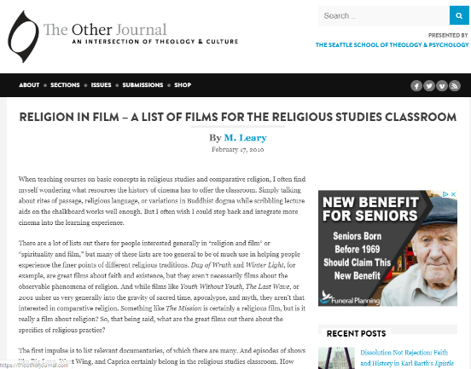](https://theotherjournal.com/2010/02/17/religion-in-film-a-list-of-films-for-the-religious-studies-classroom/)**

*Presented by the Seattle school of theology & psychology*



**TED Talks**

|  |  |  |
| --- | --- | --- |
| **Why would God create a tsunami?** | In the days following the tragic South Asian tsunami of 2004, the Rev. Tom Honey pondered the question, "How could a loving God have done this?" Here is his answer. |  |
| **On reading the Quran** | Lesley Hazleton sat down one day to read the Qur’an. And what she found -- as a non-Muslim, a self-identified "tourist" in the Islamic holy book -- wasn't what she expected. With serious scholarship and warm humor, Hazleton shares the grace, flexibility and mystery she found, in this myth-debunking talk. |  |
| **Atheism 2.0** | What aspects of religion should atheists (respectfully) adopt? Alain de Botton suggests a "religion for atheists" -- call it Atheism 2.0 -- that incorporates religious forms and traditions to satisfy our human need for connection, ritual and transcendence. |  |
| **Why does the world exist? An epic poem by Jim Holt** | Philosopher and writer Jim Holt skips right past the dumb quibbling questions and right to the heart of the great existential mystery: Why something, instead of nothing? Why does the universe exist? And why are we in it? The super-ultimate why question. |  |
| **Science can answer moral questions** | Questions of good and evil, right and wrong are commonly thought unanswerable by science. But Sam Harris argues that science can -- and should -- be an authority on moral issues, shaping human values and setting out what constitutes a good life. |  |

**Getting ready to study…..**

[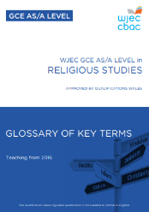](https://www.wjec.co.uk/media/i01dsjkr/wjec-gce-religious-studies-glossary.pdf)

Use the glossary of Key Terms.

|  |  |
| --- | --- |
|  | Using the letters **A-Z** try and think of one word starting with each letter related to the subject. |
|  | Create a **glossary** of terms that you are not familiar with. |
|  | **Circular Definition**: Start with a key word and find the definition in a dictionary. Choose a key term from the definition and look up that new word in the dictionary. Choose a key term from the new definition and look up that new word in the dictionary. How many key terms can you look up before your original term appears in the definition? |
|  | **Concept mapping**: Create your own image to map out concepts. Familiarise yourself with a concept E.g. reincarnation, atonement, Oedipus complex etc… then map out an image that simplifies that concept. Include key terms, useful images, pictures etc… You may want to create a concept map, then try and explain it to someone else. |
|  | **Biography**: Find out who are the key people that will be studied in your course (especially useful for the study of Ethics or Philosophy… use the specification). Create a short biography of the key thinkers and include the key terms associated with that person – E.g. Thomas Aquinas – Natural Law. |
|  | Download and read relevant articles from ‘Challenging Religious Issues’. Click the image on the left. Articles contain tasks that support thinking further about the topics covered in the journals. A list of the topics covered in the 15 published journals can be found on <http://www.st-marys-centre.org.uk/resources/Aleveljournal.html> |
| Skills - Cartoon Green Word. Business Concept. Stock Illustration ... | **Skills Mapping**: Create list of the skills that you used for GCSE Religious Studies. What skills do you think you are going to need for ‘As’ Religious Studies? Look at the image below: Which skills have you used or going to use? How did/are you going to use them? E.g. I used **research** skills whilst learning about Muslim Prayer and I was able to **evaluate** how it demonstrated commitment to Muslim religious beliefs. |



Smart Search

The Internet allows us to find huge quantities of information on just about anything. Whilst it means that we can research any topic with relative ease, it does create a few problems. How can we trust that the information is reliable? Anybody can write anything they want and post it on the Internet, so we can’t always be sure that what we’re reading is the truth, and not what ‘someone’ wants us to think. We can check information on Internet sites that we know are reliable, such as the BBC website. How do we narrow an Internet search to find what we’re looking for? The Internet has so much content that it often takes time to find the information we are looking for, and even then it might not be true. The following commands in Google allow us to narrow our searches.

|  |  |  |
| --- | --- | --- |
| command | example | explanation |
| “ ” | “exact phrase search” | placing speech marks on either end of the search term will limit the search to just those words |
| - | Religion-Christian | will search for sites that contain both ‘religion’ and ‘Christian’ |
| ~ | Religious~rituals | will search for words related to rituals |
| … | 1914…1918 | will show all the results for 1914, 1915, 1916, 1917 and 1918 |
| define: | define:word | will show the definition of the word ‘word’ |
| site: | site:bbc.co.uk religion  site:co.uk ________  site:ac ________  site:edu ________  site:ac.uk ________ | this will only search for the term ‘religion’ on internet sites ending in bbc.co.uk  will search from sites ending in .co.uk  To search on sites in other countries for example ‘hajj’ on Saudi Arabian websites type site:sa hajj  A list of ‘domains’, the letters to focus searches to a particular country, can be found at http://en.wikipedia.org/wiki/List_of_Google_domains  will search from particular universities from around the world  will search from universities generally in the USA  will search university sites from the UK |
| filetype: | filetype:ppt religion  filetype:pdf  filetype:doc | will only search for PowerPoints entitled religion  will only search for Adobe Acrobat files  will only search for Word documents  Combining the two will focus searches for particular filetypes on specific websites  Filetype:ppt site:ac.uk euthanasia will search for PowerPoints on euthanasia on university sites in the UK |
| By pressing ‘ctrl’ and ‘f ’ at the same time you can search for any word on the web page you are looking at. This is useful for websites that have a large amount of text. | | |

**Social Media**

Suggestions of people to follow on Twitter:

* Interfaith Week – supporting interfaith understanding and dialogue.

@IFWeek

* Umbrella organisation representing Islamic institutions, schools, and mosques.  Promoting Interfaith and

Community Cohesion in Wales. @MuslimWales

* News, teaching resources and advice for WJEC Religious Studies qualifications. @WJEC_RS
* Ancient philosophy quotes @AncntPhilosophy
* For all those who love the world of ideas. @philosophynws
* Ethical and philosophical thought summed up in Lego @EthicsInBricks
* The Online Centre for Religious Education (OCRS) @_ocrs_
* ABC Religion and Ethics @ABCReligion
* Oxford Philosophy @OUPPhilosophy
* Bible Project @bibleproject
* ZigZagRS @ZigZagRS
* AlevelRE @AlevelRE
* Candle Conferences @puzzlevardy
* Pencoed RE @pencoedRE
* Miss Hill – St Teilos @stteilos_LH



**Keeping it Fresh……..**

[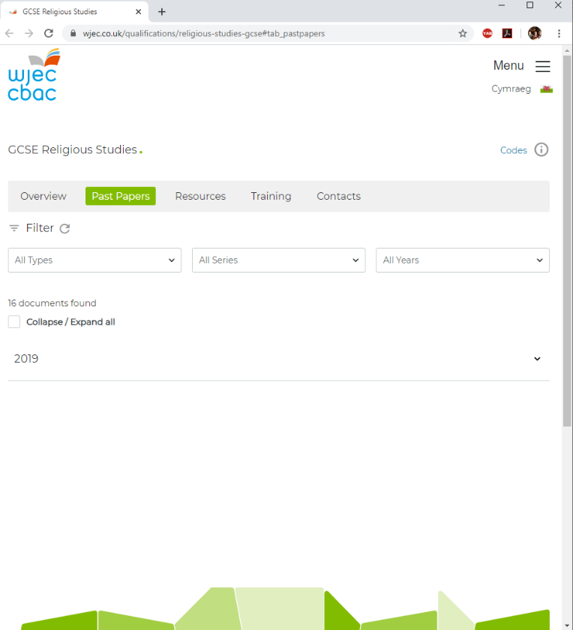](https://www.wjec.co.uk/en/qualifications/religious-studies-gcse#tab_pastpapers)

It is important to keep the knowledge you have gained at GCSE fresh in your mind ready to start your A levels in September.

Why not spend some time looking over some past papers and using the mark schemes to assess how well you’ve done.

Religious Studies GCSE – Past Papers and Marking Schemes: